ISSUE #1 January 2020
Corby+Fellas News

Arboretum, one of Ireland’s premier garden centres, has installed WinRetail

Corby & Fellas Ltd. are delighted to announce that Arboretum - one of Ireland’s premier garden centres - has just installed WinRetail, our innovative EPoS and Retail Management System.

Arboretum are Bord Bia’s (Irish Food Board) first ever Five Star Garden Centre and have won numerous other awards including Best Customer Service and Retail Excellence Store of the Year 2015.

After long and exhaustive research by Fergal and Barry Doyle, the company decided to install WinRetail. It was felt that C&F and WinRetail both had a good reputation and that the software’s features and its flexibility would satisfy Arboretum’s needs both now and in the future.

The migration of data from the existing to the new system was, as is so often the case, a challenge. Nonetheless this was achieved without difficulty and gave an opportunity to identify and ‘tidy up’ incomplete and duplicate stock records.

Once Arboretum had decided to adopt WinRetail they were keen to start benefitting from its many features as quickly as possible. So, they opted to implement the CRM sub-system, the integrated Web Site (including full ecommerce) and linked Events and Booking system from ‘day one’. Possibly a risky strategy, but Arboretum’s confidence, skill and enthusiasm ensured a successful launch.

Corby & Fellas are very happy to welcome Arboretum Garden Centre and pleased that such a prestigious garden centre should be our first customer in the Republic of Ireland. We look forward to a long and harmonious association.

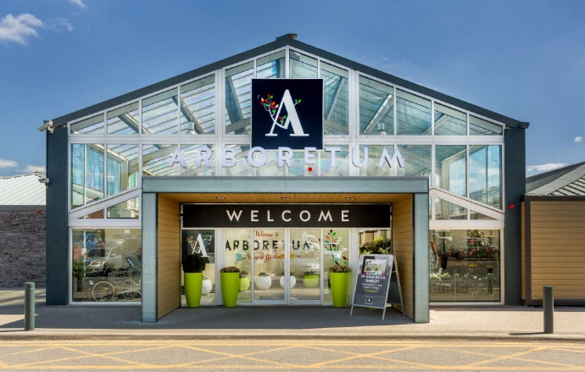
C+F NEWS

